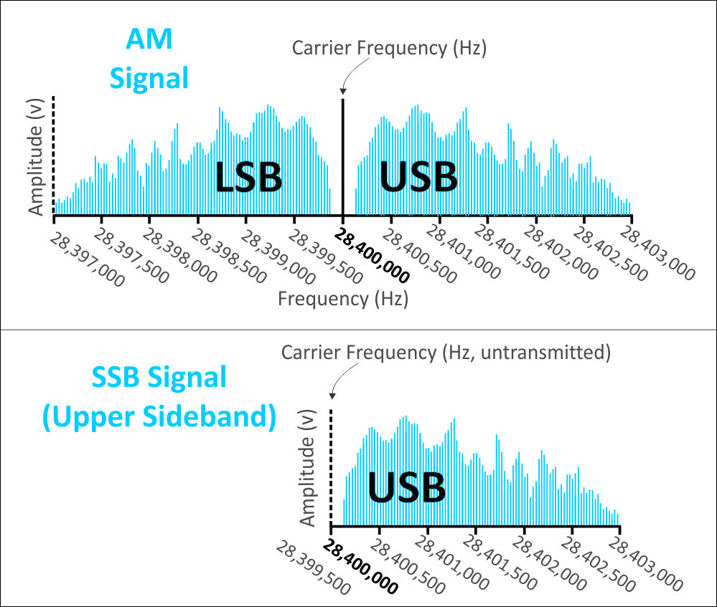
The unwanted sideband and the carrier signal are suppressed (filtered out), allowing all available power to be used to transmit the remaining sideband, increasing efficiency and decreasing bandwidth.

